|  |  |  |  |  |
| --- | --- | --- | --- | --- |
| Van Vet J, 2017, 28 (3) 169-172 | | | | |
|  | | | | |
|  | | | | |
|  |  | | |  |
|  | | |  |
| Van Veterinary Journal | | |
| http://vfdergi.yyu.edu.tr | | |
|  | | |  |
|  | | | | |
|  | | | | |
| ISSN: 2149-3359 | **Case Report** | | e-ISSN: 2149-8644 | |
|  | | | | |
| **Operative Treatment of Traumatic Thoracolumbar Luxations in Two Cats by a Method of Simple Spinal Process Stabilization** | | | | |
| Ramazan GÖNENCİ Ziya YURTAL Mehmet Zeki Yılmaz DEVECİ | | | | |
| *Mustafa Kemal University, Faculty of Veterinary Medicine, Department of Surgery, Hatay, Turkey* | | | | |
| Received: 06.10.2016 | | Accepted: 14.02.2017 | | |
|  | | | | |
|  | | | | |
| **SUMMARY** | In this case report, the operative treatment outcomes of spinal vehicular trauma was evaluated in two cats that brought to Mustafa Kemal University Veterinary Faculty Surgery Clinic. The cases were clinically paraplegic, and a thoracolumbar luxation between Th13 and L1 in one and a thoracal fracture-luxation between Th11 and Th12 in the latter were diagnosed radiographically. The cases were operated by a method of simple spinal process stabilization, using two rods stabilized to processus spinosus of related vertabrates by cerclage wires. It was not observed any postoperative complication and concluded that this method was useful. | | | |
| ***Key Words:*** *Cat, Simple spinal process stabilization, Traumatic spinal luxation* | | | |
|  |  | | | |
|  |  | | | |
| **ÖZET** | **İki Kedide Karşılaşılan Travmatik Torakolumbal Çıkığın Basit Spinal Proses Stabilizasyon Metodu ile Operatif Sağaltımı** | | | |
| Bu olgu raporunda, trafik kazası sonucu Mustafa Kemal Üniversitesi Veteriner Fakültesi Cerrahi Kliniği’ne getirilen iki kedide karşılaşılan spinal travmanın operatif sağaltım sonuçları değerlendirildi. Klinik olarak paraplejik olan bu olguların radyografilerinde, Th13 - L1 arasında torakolumbal çıkık ve Th11 - Th12 arasında torakal kırıklı çıkık tanısı konuldu. Olgular komşu Processus spinalislere iki pinin serklaj telleri ile tutturulması prensibine dayanan basit spinal proses stabilizasyon metodu ile opere edildi. Herhangi bir postoperatif komplikasyon gözlenmeyen bu metodun faydalı olduğu sonucuna varıldı. | | | |
| ***Anahtar Kelimeler:*** *Basit spinal proses stabilizasyonu, Kedi, Travmatik spinal çıkık* | | | |
|  | | | | |

**INTRODUCTION**

Vehicular trauma, bite and gunshot wounds are the most common causes of thoracolumbar spinal fractures and luxations in dogs and cats depending on the animal’s position at the time of impact, the type of force conveyed, the area of impact and inherent strengths and weaknesses of the vertebral column (Bali et al. 2009; Krauss et al. 2012). Reduction or loss of voluntary movements, alteration of spinal reflexes, changes in muscle tones and sensory dysfunctions are seen to a varying degree in all animals which have a spinal cord injury. After physical and neurological examinations; the major purposes of complete radiographical evaluation of the vertebral column are precise localization of lesions, demonstration of multiple lesions not suspected based on results of a neurological examination, assessment of indications for surgery and determination of the most appropriate surgical procedure that might be used. The most important prognostic factor after spinal cord trauma is the presence or absence of deep pain sensation. Regardless of radiographical findings, the assessment of neurological status by careful neurological examination is the most important point at establishing prognosis of spinal cord injury (Sturges and Le Counter 2003). The report was aimed the evaluation of operative outcomes performed to thoracolumbar luxation and thoracal fracture-luxation cases in two cats exposed to motor vehicle accidents.

**CASES**

A 3-year-old, 3 kg weighted, male, mix breed cat and a 3-month-old, 0.5 kg weighted, female, mix breed cat had exposed to a motor vehicle accident a few days before and brought to Mustafa Kemal University Veterinary Faculty Surgery Clinic (Fig. 1). The former (Case 1) was not able to stand up and use its hind limbs. In addition to the paraplegie, it was seen deformation, gibbosity and local pain at the thoracolumbar region. Patellar, cranial tibial and gastrocnemial reflexes and deep pain were observed to be absent in neurological examination but anal reflex was present. A thoracolumbar luxation was diagnosed between thoracal 13 (Th13) and lumbar 1 (L1) vertebrates by a lateral radiogram (Fig. 1). The latter (Case 2) was paraplegic but flexion reflexes were observed mildly in hind limbs neurologically. Other reflexes and deep pain were absent in paraplegic region. Gibbosity and deformation at the region were obviously discernible. A thoracal fracture-luxation was radiographically diagnosed (Fig. 2) between Th11 and Th12 vertebrates.

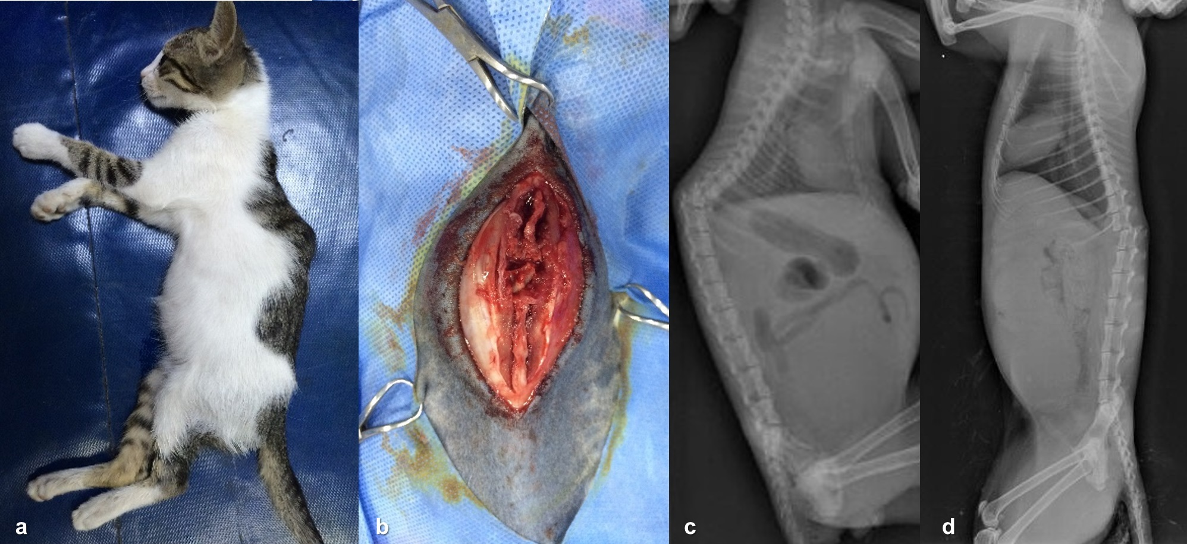

**Figure 1.** The view of case 2 (a) and its operation site (b). Preoperative lateral radiographic views of the thoracolumbar luxation between Th13 and L1 in the case 1 (c), and the thoracal fracture-luxation between Th11 and Th12 in the case 2 (d).

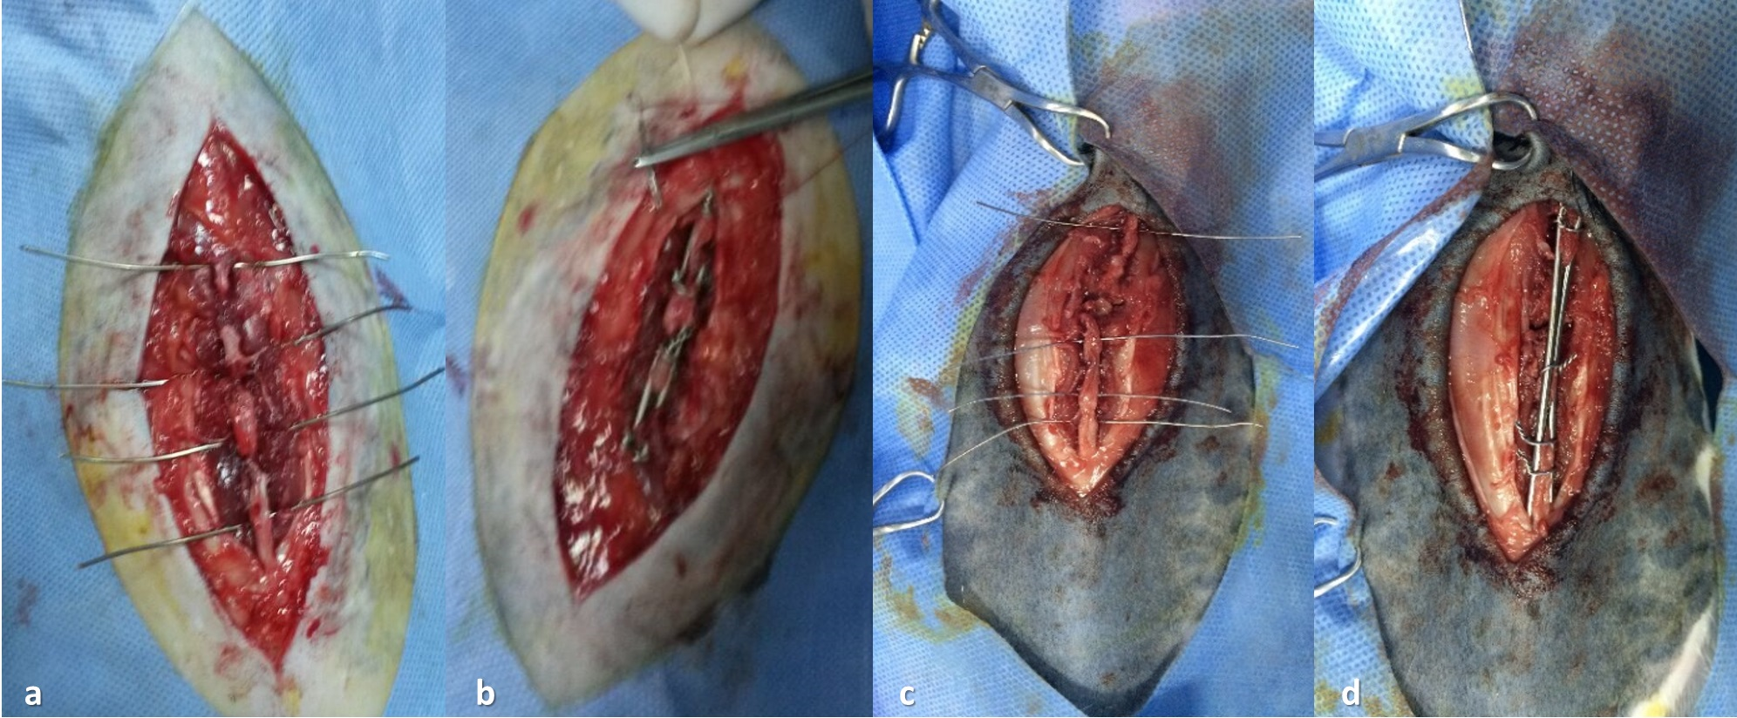

**Figure 2.** Placing of cerclage wires through the holes opened at the basis of related spinous processes in case 1 (a) and 2 (c). The fixation of two rods in case 1 (b) and 2 (d).

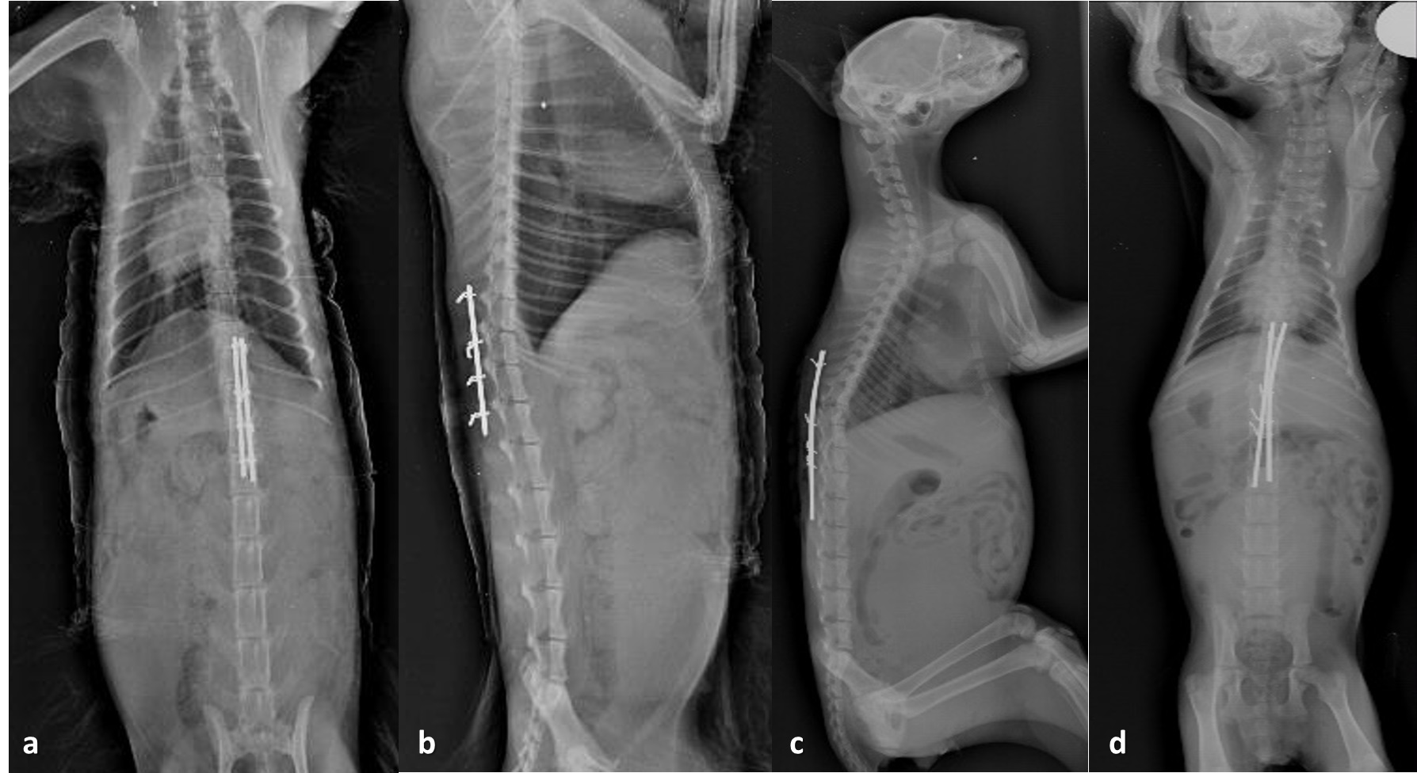

**Figure 3.** It was seen that normal anatomical realignment and stabilization were provided in case 1 (a-b) and case 2 (c-d) in postoperative ventrodorsal and lateral radiographic views.

The surgical intervention was seen necessary after the examinations. Patients were anesthetized using of 2 mg/kg im xylazine (20 mg/ml Alfazyne® EgeVet) and 20 mg/kg im ketamine (100 mg/ml Alfamine® EgeVet). The surgery was consisted of stabilization of the spinal luxations by two steinmann pins (rods) that had attached to spinous processes with cerclage wires (Fig. 2). Following a dorsal midline skin incision extending from a minimum of two cranial and caudal vertebras to the luxations aseptically. The epaxial musculature was gently elevated down from the spinous processes with the attention of protecting the muscle attachments to articular facets after dorsal fascial incision. Reduction and stabilization of luxations were achieved by double pointed bone forceps that were applied on the dorsal spinous processes and carefully upward traction to normal anatomical alignment of spinal segments. The chosen pins were long enough to encompass at least two of spinous processes cranial and caudal to the luxations bilaterally. Pins (1.6 and 2 mm in diameters for Case 2 and 1 respectively) were fixed by cerclage wires of 1 and 0.5 mm in diameters for Case 1 and 2 respectively passed through the holes that were opened at the basis of related spinous processes by an orthopedic drill. The surgery was ended after the dorsal fascia, the subcutaneous tissue and the skin were finally closed in a routine fashion. In postoperative examination, vertebral situs was seen to be normal on the radiograms (Fig. 3). Whereas flexion reflexes were observed to be present clinically in hind limbs of Case 1 after the operation, there were not any sensory functions and muscle tones in Case 2 at first. These findings begun to indicate the reflexes one week and stood up two weeks after the surgery. But this case died at 23th day of the operation because of being tromboembolus probably. On the side, presences of spontaneous defecation and urination were informed by the owner in postoperative period.

**RESULTS and DISCUSSION**

Owing to the possibility of idiopathic further spinal cord injury of a patient positioned in dorsal recumbency, only lateral radiographs have been recommended at preoperative period (Sturges and Le Counter 2003). So, it was preferred only lateral projections in the cases due to being suspected fractures (Fig. 1). Bali et al. (2009) mentioned that the dislocation degree and axis deviation have been associated with a worse outcome in dogs but not in cats. This was obvious in the cats and did not occur any problem in recovery of the cases. Vertebral fractures and luxations due to road traffic accidents have been stated as 40% to 60% roughly (Feeney and Oliver 1980; Selcer et al. 1991;Hawthorne et al. 1999;Bruce et al. 2008). In a retrospective study (Marioni-Henry et al. 2004), it has been denoted that the cat’s traumatic caused spinal cord diseases were 14% in total, and 7% of them were secondary to vertebral column injury. Luxations have been found in dogs more than cats and large dogs also have been found in predisposition to luxations than small dogs. A possible explanation for the lower incidence of luxations of the vertebral column in cats (6%) and small dogs (13%) compared to large dogs (30%) may be due to anatomical differences. The vertebrae of cats and small dogs are far more delicate and therefore may be in more predisposition to additional fractures than the bulkier vertebrae of larger dogs. Combined fracture and luxations have been significantly seen more often in cats (65%) than dogs (37%) because of the comparably thin vertebral bone which may render it more susceptible to additional fractures (Bali et al. 2009).

Unstable and neurologically disrupted patients especially those with severe deficits usually were treated by the surgery (Jeffery 2010). Proper and timely surgical intervention can improve the physiological environment of the spinal cord and allow for maximal neurological improvement (Sturges and Le Counter 2003). Despite of controversy about intervention time, it recently has been an improving consensus in favor of early surgical intervention (Jeffery 2010). Surgical intervention is also the most effective method for achieving the relief of spinal cord edema and compression, control of intra-extramedullary hemorrhage, removal of bone fragment or intervertebral disc material from the vertebral canal, realignment and stabilization of the vertebral column within optimal time period for recovery of spinal cord function (Sturges and Le Counter 2003). Removing of small bone fragments is also controversial and it has been suggested unnecessary (Chakera et al. 1988;Dai 2001; Leferink et al. 2003).

Objectives of surgical treatment in thoracolumbar spine fractures and luxations include spinal cord and nerve root decompression, and vertebral fracture and luxation stabilization. The stabilization can provide by multiple procedures with only techniques or various configurations of techniques. These include Steinmann pins and PMMA (polymethylmethacrylate) bone cement, vertebral body and dorsal spinous process plates, modified segmental spinal fixation, spinal stapling, external fixators or a combination of these techniques. The overriding primary aims were to limit further damage and to relieve compression by reestablishing normal position to the vertebral canal and intervertebral foramina (Lanz et al. 2000; Seim 2002; Voss and Montavon 2004; Jeffery 2010; Krauss et al. 2012). In this study, it was applied simple spinal process stapling by two Steinmann pins placed through the base of each spinous processes and cerclage wires twisted around the pins and penetrated the spinous process bases. It did not require any additional surgical applications such as vertebral decompression and other only or combined stabilization techniques mentioned above. Results of complications following the surgery are quite common and are often associated to bladder dysfunction and limb disuse. Each stabilization technique has advantages and disadvantages. Complications associated with these methods include iatrogenic spinal cord injury, pin migration, especially postoperative infection related to PMMA implants, inappropriate screw placement, iatrogenic pneumothorax, screw and plate migration, plate slippage and fracture of the dorsal spinous process, fatigue fractures of pins and wires (Seim 2002;Jeffery 2010). In simple spinal process stabling method presented in the case report, it can be waited to be complications such as pin migration or spinal process fracture postoperatively. These postoperative complications in the cases were hoped to be quite low because of young age, low weight and small body size of the cats, and less severity of the injuries. Conclusively, the technique performed in this report was found to be useful because of being easy applying, relatively inexpensive, and appropriate for thoracolumbar vertebral luxations in cats.

**REFERENCES**

**Bali MS, Lang J, Jaggy A, Spreng D, Doherr MG, Forterre F (2009).** Comparative study of vertebral fractures and luxations in dogs and cats. *Vet Comp Orthop Traumatol*, 22, 47-53.

**Bruce CW, Brisson BA, Gyselinck K (2008).** Spinal fracture and luxation in dogs and cats: A retrospective evaluation of 95 cases. *Vet Comp Orthop Traumatol*, 21 (3), 280–284.

**Chakera TM, Bedbrook G, Bradley CM (1988).** Spontaneous resolution of spinal canal deformity after burst-dispersion fracture. *Am J Neuroradiol*, 9 (4), 779–785.

**Dai LY (2001).** Remodeling of the spinal canal after thoracolumbar burst fractures. *Clin Orthop Relat Res,* 382, 119–123.

**Feeney DA, Oliver JE (1980).** Blunt spinal trauma in the dog and cat: insight into radiographic lesions. *J Am Anim Hosp Assoc*, 16(6), 885–890.

**Hawthorne JC, Blevins WE, Wallace LJ, et al (1999).** Cervical vertebral fractures in 56 dogs: A retrospective study. *J Am Anim Hosp Assoc*, 35(2), 135–146.

**Jeffery ND (2010).** Vertebral fracture and luxation in small animals. *Veterinary Clinics of North America: Small Animal Practice*, 40(5), 809-828.

**Krauss MW, Theyse LFH, Tryfonidou MA, Hazewinkel HAW, Meij BP (2012).** Treatment of spinal fractures using Lubra plates. A Retrospective clinical and radiological evaluation of 15 cases. *Vet Comp Orthop Traumatol*, 25, 1-6.

**Lanz OI, Jones JC, Bergman R (2000).** Use of an external fixator to correct spinal fracture/luxation and instability in three dogs. *Vet Neurol Neurosurg J*, 2(1), 1-8.

**Leferink VJ, Nijboer JM, Zimmerman KW, et al (2003).** Burst fractures of the thoracolumbar spine: Changes of the spinal canal during operative treatment and follow-up. *Eur Spine J*, 12(3), 255–260.

**Marioni-Henry K, Vite CH, Newton AL, et al (2004).** Prevalence of diseases of the spinal cord of cats. *J Vet Intern Med*, 18(6), 851–858.

**Seim HB (2002).** Surgery of the thoracolumbar spine. In: Small Animal Surgery, 2nd Edition, Fossum TW (Ed), 1269–1301, Mosby, St. Louis, Missouri.

**Selcer RR, Bubb WJ, Walker TL (1991).** Management of vertebral column fractures in dogs and cats: 211 cases (1977-1985). *J Am Vet Med Assoc*, 198(11), 1965–1968.

**Sturges BK, Le Counter RA (2003).** Vertebral fracture and luxations. In: Textbook of Small Animal Surgery, 3rd edition, Slatter D (Ed), 1244-1260, W.B. Saunders, Philadelphia.

**Voss K, Montavon PM (2004).** Tension band stabilization of fractures and luxations of the thoracolumbar vertebrae in dogs and cats: 38 cases (1993–2002). *J Am Vet Med Assoc*, 225 (1), 78–83.