|  |  |  |  |  |
| --- | --- | --- | --- | --- |
| Van Vet J, 2017, 28 (1) 37-40 | | | | |
|  | | | | |
|  | | | | |
|  |  | | |  |
|  | | |  |
| Van Veterinary Journal | | |
| http://vfdergi.yyu.edu.tr | | |
|  | | |  |
|  | | | | |
|  | | | | |
| ISSN: 2149-3359 | **Original Article** | | e-ISSN: 2149-8644 | |
|  | | | | |
| **Effects of Aflatoxin on Kidney and Protective Effectiveness of  Esterified Glucomannan in Ram** | | | | |
| Fatma ÇOLAKOĞLU1 Hasan Hüseyin DÖNMEZ2 | | | | |
| *1 Karamanoglu Mehmetbey University, Faculty of Health Science, Department of Nutrition and Dietetics, Karaman, Turkey 2 Selcuk University, Faculty of Veterinary Medicine, Department of Histology and Embryology, Konya, Turkey* | | | | |
| Received: 06.10.2016 | | Accepted: 21.11.2016 | | |
|  | | | | |
|  | | | | |
| **SUMMARY** | In this study, the effects of total aflatoxin (AF) given orally on kidney in Merino rams were studied. In addition, this study was conducted in order to evaluate the efficacy of an esterified glucomannan (EG) for protection against to aflatoxicosis. One year-old 32 Merino rams were divided into four equal groups. Rams were fed through the 92 days. Control group (C) fed with the commercial feed. AF group fed with commercial feed added 250 µg/day of total AF. EG group fed with commercial feed added 2 g/day of EG. AF+EG group fed with commercial feed added 250 µg/day of total AF and 2 g/day of EG. At the end of the 92 day after cessation of the animals, tissue samples were taken from the kidney in order to perform histological structure. Degeneration and spills in the tubular epithelial cells of kidney were observed in the AF group. Massive hyperemia was observed in the renal vessels. In conclusion, the adverse effects causing by aflatoxicosis on the kidney could be ameliorated by adding EG to the ration. | | | |
| ***Key Words:*** *Aflatoxin, Glucomannan, Kidney Histology, Ram* | | | |
|  |  | | | |
|  |  | | | |
| **ÖZET** | **Koçlarda Aflatoksinin Böbrek Üzerine Etkileri ve Esterifiye Glukomannanın Koruyucu Etkinliği** | | | |
| Bu çalışmada Merinos ırkı koçlara ağızdan verilen total aflatoksinin (AF) böbrek üzerine etkileri ile glukomannanın (EG) koruyucu etkinliği değerlendirildi. Çalışmada 1 yaşında 32 adet koç 4 eşit gruba ayrıldı. Beslemeye 92 gün devam edildi. Kontrol (K) grubuna ticari yem; AF grubuna ticari yem ile günlük 250 µg AF; EG grubuna ticari yem ile günlük 2 gr EG; AF+EG grubuna ise ticari yemle birlikte günlük 250 µg AF ve 2 gr EG verildi. 92. günün sonunda hayvanlar kesildikten sonra böbrekteki histolojik yapıyı göstermek için örnekler alındı. AF grubunun böbrek tübüllerinde dejenerasyon ve dökülmeler, böbrek damarlarında ise yoğun hiperemi gözlendi. Sonuç olarak; aflatoksikozun böbrek üzerindeki olumsuz etkilerinin yeme EG ilave edilerek iyileştirilebildiği ortaya konmuştur. | | | |
| ***Anahtar Kelimeler:*** *Aflatoksin, Böbrek Histolojisi, Glukomannan, Koç* | | | |
|  | | | | |

**INTRODUCTION**

Mycotoxins are toxic metabolites synthesized by some naturally occurring fungi under suitable physical, chemical and biological factors (Agag 2004). Among them are the aflatoxins (AF) which are produced by the fungi *Aspergillus flavus* and *A. parasiticus* (Wilson and Payne 1994). They not only contaminate foodstuffs but are also found in edible tissues, milk and eggs after consumption of contaminated feed by farm animals (Pohland 1993; Fink 1999). Furthermore, AFs have been found in human cord blood and apparently can enter the developing fetus in humans and animals (Appelgren and Arora 1983; Denning 1987). It is well known AFs are carcinogenic, teratogenic, mutagenic and immunosupression (Oguz et al. 2003). The liver is the target organ for aflatoxicosis (Lakkawar et al. 2004). There is evidence that it has harmful effects on the kidneys, though not as much as on the liver (Eraslan et al. 2003).

Prevention of feed and feedstuffs from possible mould growth and AF contamination is very important (Ozen et al. 2009). Practical and cost-effective methods for detoxification of AF containing feed and feedstuff are in great demand (Basmacıoglu et al. 2005). Since the early 1990s, the adsorbent-based several studies have been performed to detoxify AF in contaminated food and foodstuffs and to minimize the deleterious effects of AF (Kececi et al. 1998; Oguz et al. 2003). An approach to the problem has been the usage of non-nutritive and inert adsorbents in the diet to bind AF and reduce the absorption of AF from the gastrointestinal tract (Oguz 2011). The non-nutritive clays such as aluminosilicates, zeolites, bentonites, and clinoptilolite were preferred by the researchers (Kececi et al. 1998; Oguz et al. 2003). Recent years, researchers suggested that the best approach to decontamination should be degradation by biological materials giving a possibility of AF removal under moderate conditions, without using harmful chemicals and without significant losses of the nutritive value and palatability of detoxified feed and feedstuffs (Yıldırım et al. 2011). Yeast cell walls, particularly those of *Saccharomyces cerevisiae* (SCE), are an enviromentally friendly alternative to other adsorbents, because they are easily biodegraded (Yiannikouris et al. 2005). The structure of these cells and the nature of the polysaccharides they contain , ie., glucan and mannan, have been studied extensively. Yeast cell walls may form complexes with dietary toxins, thereby limiting toxin absorption in the digestive tract. The ability of yeast cell walls to bind toxins is increased by their large surface area (Yiannikouris et al. 2003). Live yeast (*Saccharomyces cerevisiae;*SCE*)* initially used as a performance promoter in the early 1990s, was found to have beneficial effects on aflatoxicosis (Stanley et al. 1993). The beneficial effects of SCE have been attributed to mannan in the cell wall of SCE. Mannan was then extracted and esterified with glucan. Esterified glucomannan (EG) showed considerably high binding ability (80-97%) with AF (Basmacıoglu et al. 2005), and it has been preferred for detoxification of AF in poultry animals.

The aim of this study, the effects of total AF given orally on kidney in Merino rams was studied. In addition, this study was conducted in order to evaluate the efficacy of an EG for protection against to aflatoxicosis.

**MATERIALS and METHODS**

**Animals and Diet**

Approval for the present study was obtained from the Animal Ethics Committee of the Faculty of Veterinary Medicine of the Selcuk University (2008/061). The study was created from the TUBITAK-TOVAG project entitled ‘‘Effects of Aflatoxin on Semen Quality, Testicular Histology, and Hyaluronidase Enzyme Activity, and Protective Effectiveness of Esterified Glucomannan in Ram’’.

Thirty-two Merino rams were approximately purchased 1-year-old (12-14 months old). Animals were examined for general health. Antiparasitic ivermectin injection (Avromec-F, 1ml/50 kg) and oksifendazol (oxa-F, 1 tablet/50 kg) were performed. In addition, enterotoxemia (Pluritoxiven-8, 1 ml) and smallpox vaccines were performed. For adaptation to the environment and the implementation of a new 15-day training program was applied to feeding. Individually weighted rams were divided into four equal groups. Experimental feeding was continued throughout ninety-two days. The duration of treatment (92 days) was based on a possible cumulative toxicity and the duration of spermatogenesis and spermiogenesis in ram. The rams were fed a commercial food (Table I). Water and alfalfa were given *ad libitum*. AF and EG that were mixed of 250 g commercial feed were given to animals before morning feeding and then morning feeding was continued.

**Experimental Design**

The experimental design consisted of four dietary treatments. Control group (C) fed with the commercial feed (Table I). AF group fed with commercial feed added 250 µg/day of total AF. EG group fed with commercial feed added 2 g/day of EG. AF+EG group fed with commercial feed added 250 µg/day of total AF and 2 g/day of EG. AF and EG doses which were given to animals throughout the study were calculated by pharmacologists.

**Table 1.** Composition of the commercial feed

|  |  |
| --- | --- |
| **Composition** | **Content Ratio** |
| Dry matter | %88 |
| Crude protein | %12 |
| Crude Cellulous | %12 |
| Crude ash | %9 |
| Insoluble ash in HCL | %1.0 |
| Ca | %0.6-1.6 |
| P | %0.4 |
| Na | %0.1-0.4 |
| NaCl | %1.0 |
| Metabolic energy | 2750 kcal/kg |
| Vit A | 7000 IU-kg |
| Vit D3 | 700 IU-kg |
| Vit E | 25 mg/kg |

**Aflatoxin**

The AF was produced (in the Department of Pharmacology and Toxicology, Faculty of Veterinary Medicine, University of Selcuk, Konya; Turkey) from *Aspergillus parasiticus* NRLL 2999 culture (USDA, Agricultural Research Service, Peoria, IL) via fermentation of rice by the method of Shotwell et al. (1966) with minor modifications by Demet et al. (1995). Fermented rice was sterilized in autoclave, dried at 70º C, and ground to a fine powder. According to the method reported by Vicam (1999) extraction and cleaning of AF in fermented rice was used immunoaffinity column (Down Test ®; Vicam). The amount of AF carried out by high performance liquid chromatography (HPLC) according to the method reported by Stroka et al. (2000). The amount of total AF in the fermented rice was found 73.96 ppm. The AF within the rice consisted of 84.15 % AFB1, 6.29 % AFB2, 9.13 % AFG1 and 4.25 % AFG2. (rate of return method 97.4 %; sensitivity 0.4 ppb).

**Collection and Processing of Tissue Samples**

At the end of the 92 day, Kidney tissue samples were taken from rams after scarification and were fixed in 10% neutralized buffered formaldehyde, embedded in paraffin wax and then stained with Crosman’s modification of trichrome stain in order to determine the histological structure (Ustunel and Demir 2001).

**RESULTS**

Histopathologically, no specific lesion was observed in kidney tissues from the C (Figure 1 and 2) and EG groups. In the AF group, degeneration and spills in the tubular epithelial cells (Figure 3), vascular dilation and congestion was noticed in the kidney. Especially in the renal medula region, massive hyperemia was found in the renal vessels (Figure 4). In the AF+EG group, a small number of spills in the tubular epithelial cells of renal cortex region and locally congestion in the vessels of the renal medula region were observed.

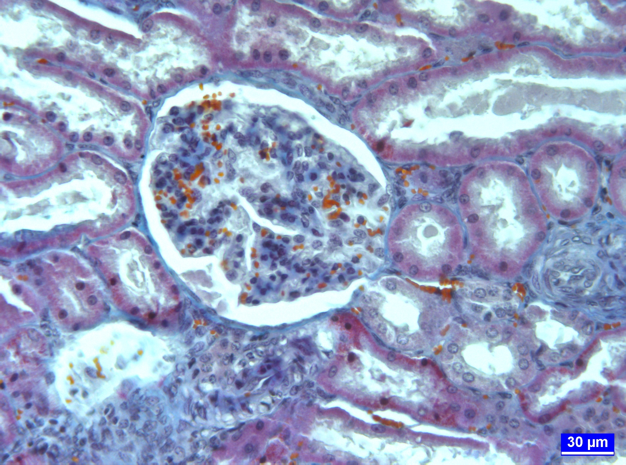

**Figure 1.** Normal histological appearance of the kidney a control group, cortexregion, trichrome staining

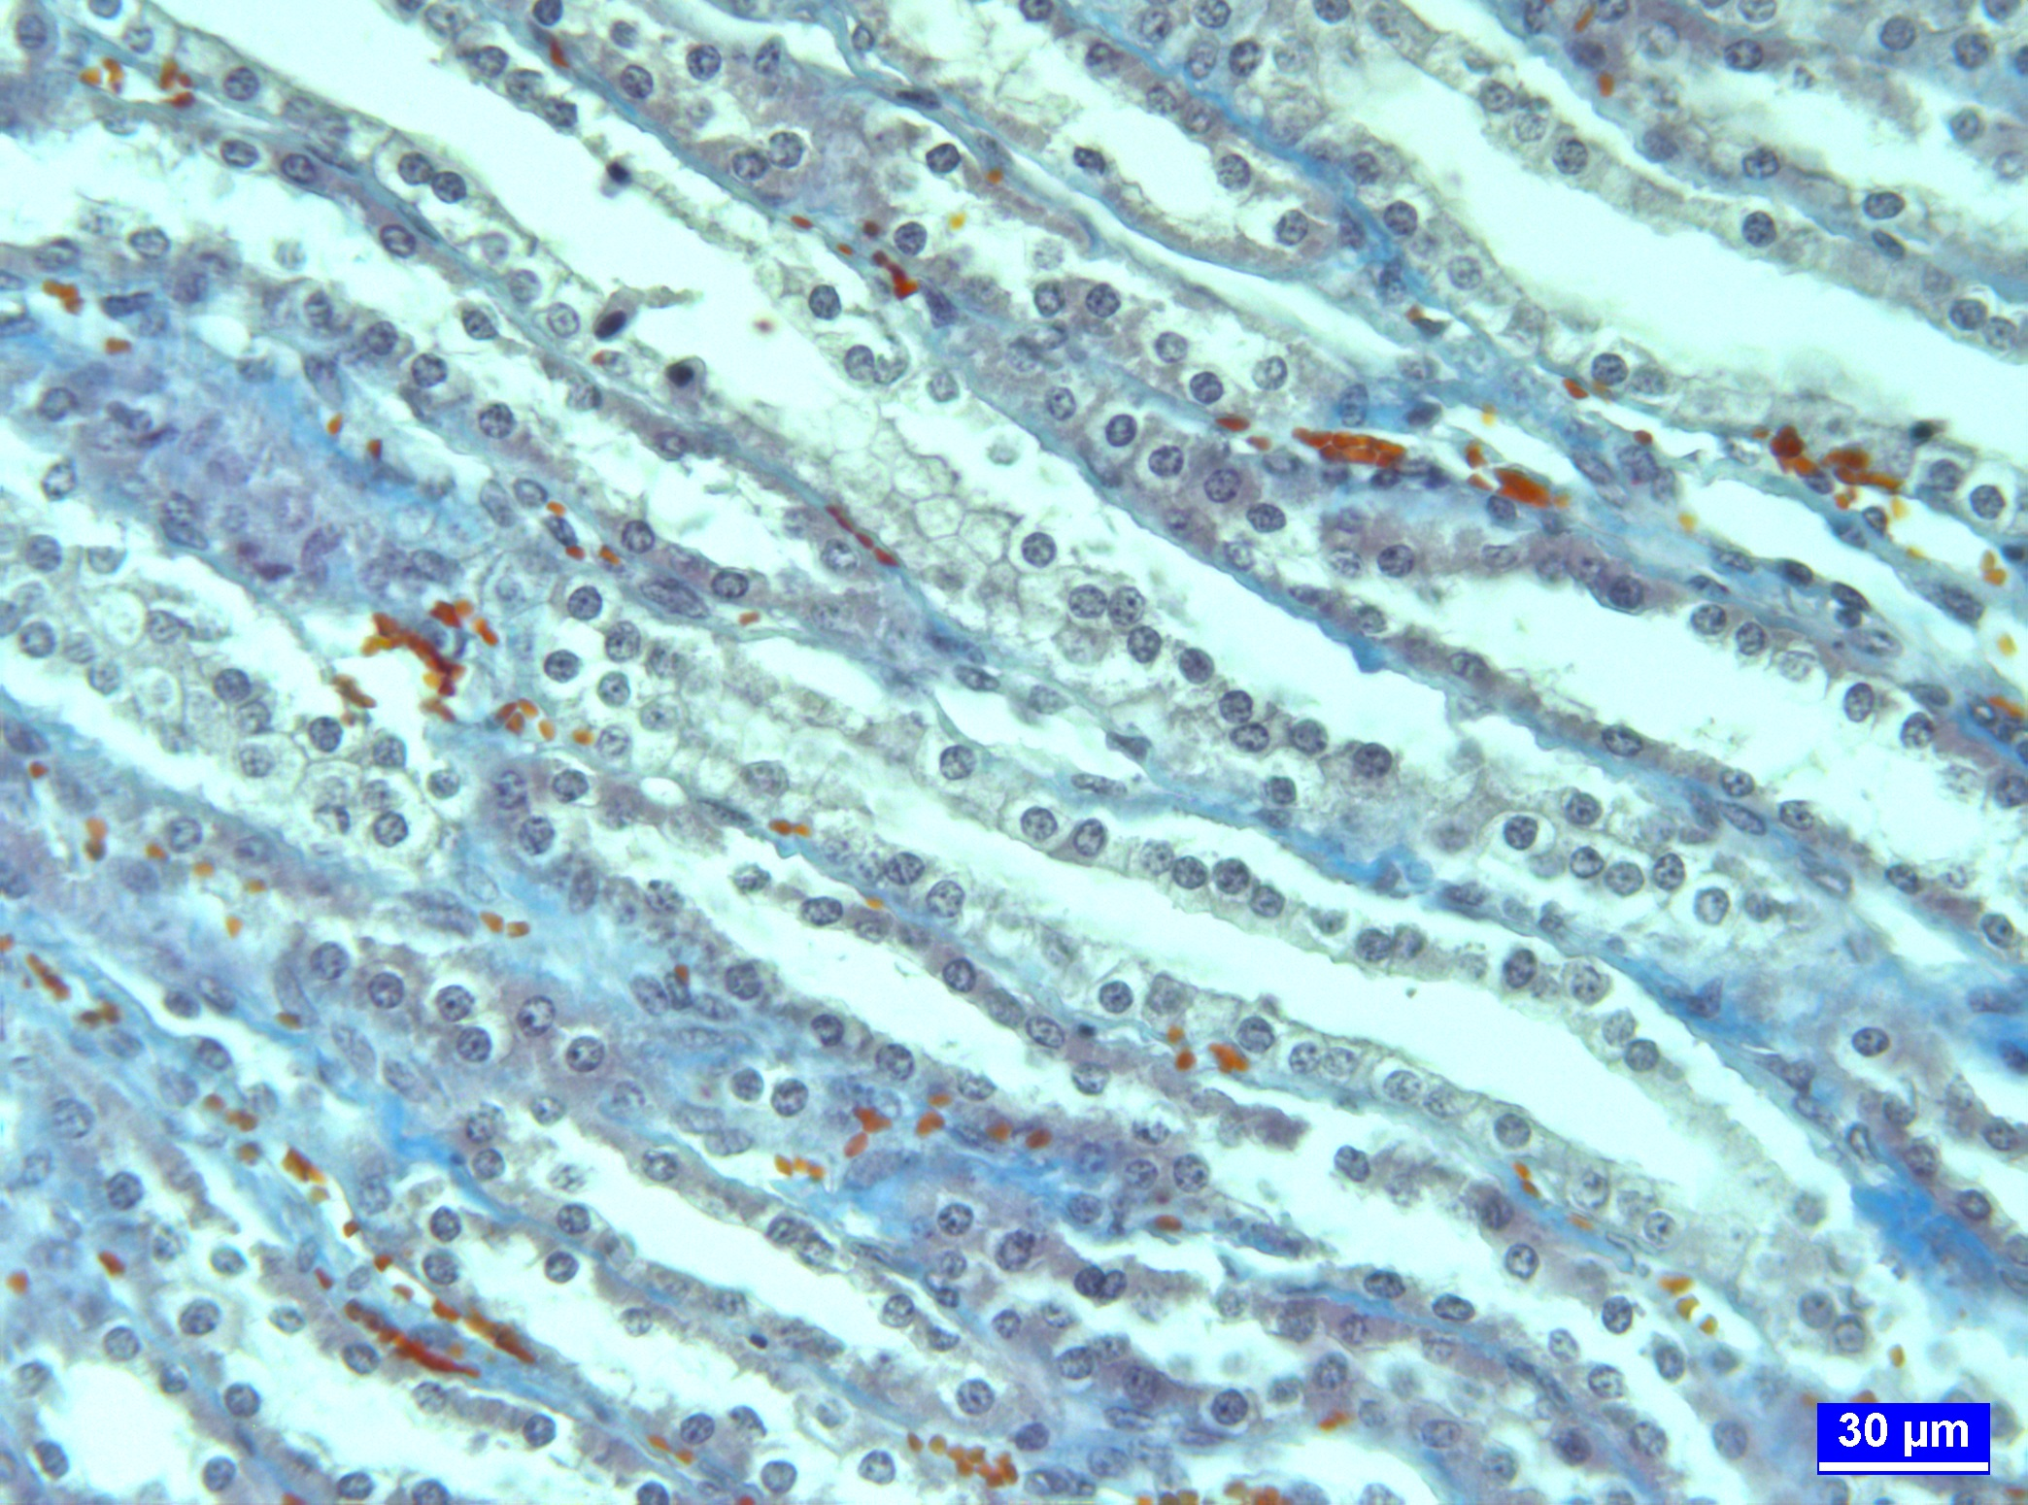

**Figure 2.** Normal histological appearance of the kidney a control group, medula region, trichrome staining

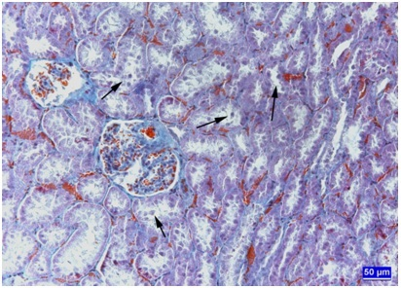

**Figure 3.** Degeneration andspills in the tubular epithelial cells in AF group (arrows), cortex region, trichrome staining

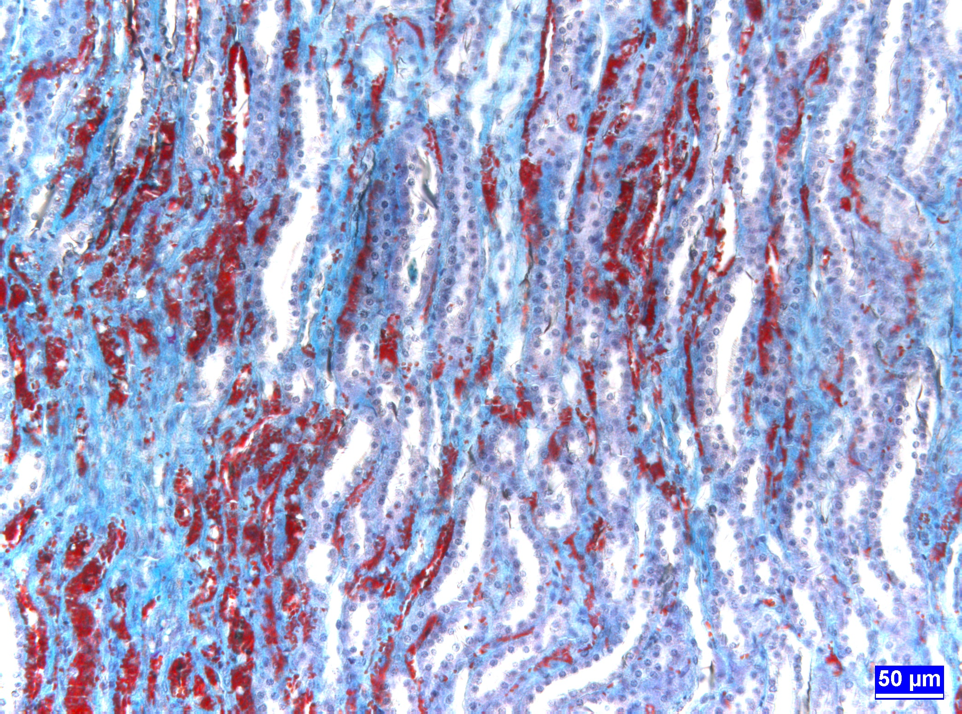

**Figure 4.** Vascular dilation and massive congestion in the renal vessels in AF group, medula region, trichrome staining

**DISCUSSION**

Although the principal target organ for aflatoxin is the liver, necrosis and hemorrhage may also occur in other organs (i.e., kidney, heart, spleen, and pancreas) depending on variables such as animal species, dose, route, and treatment protocol (Newberne and Rogers 1981). Few reports have documented renal damage in rats (Ikegwuonu et al. 1980; Maull 1988). Arora et al. (1978) reported that the kidneys also excreted AFB1 and that the renal medulla was quite sensitive to this mycotoxin. Another study by Grosman et al. (1984) demonstrated that rats are acutely sensitive to the nephrotoxic effects of a single dose of AFB1 (100 ppb). Lakkawar et al. (2004) reported that liver and kidney were the most affected organs in rabbits which fed an AFB1 contaminated diet. The effects of AFs on histopathological changes are directly correlated with the concentration of AF and the duration of the exposure (Boonyaratpalin et al. 2001). In this study, it was observed that 250 µg/day AF caused significant histopathological changes in liver in 92 days.

Some researches have reported vascular and degenerative lesions in ducks’s kidneys of AF treated group (Asplin and Carnaghan 1961; Calnek et al. 1997). In this study, we also found similar findings. Dafalla et al. (1987) was declared the epithelial cells of many renal tubules were vacuolated in broilers. A study of Ozen et al. (2009) reported moderate tubular epithelial degeneration due to AF in kidney. Yıldırım et al. (2011) were detected tubular epithelial cells were pale and swollen, sometimes necrotic in kidney. Morrissey et al. (1987) have found tubular cells necrosis with pyknotic nucleus in kidney of rats, especially in the inner parts of renal cortex. Glahn et al. (1991) reported that the target site of action of AFB1 in kidneys is the glomerular region. In our study, we also observed degeneration and spills in the tubular epithelial cells similar to previous studies. Lakkawar et al. (2004) were observed degeneration of the tubular epithelium up to the 30th day in the kidneys. At the terminal stage of the experiment, they declared the renal tubules showed a marked degeneration and hyanilization of the tubular epithelium along with widened Bowman’s spaces of glomeruli. Ortatatlı et al. (2005) were reported that the toxic effects of AF on kidney were clearly observed by feeding 100 ppb AF fed for 42 days. They have seen slight tubular degeneration in the kidney. In our study, the kidneys from animals treated with AF showed marked degeneration of renal tubules and loss of tubular epithelial cells. As a reason of this situation, AF metabolites arising from the effects of some of the enzymes which react with DNA are thought to be caused by mutations in the nucleus (Shen et al. 2005).

In histological examination of kidneys in the AF group,Lakkawar et al. (2004) were observed initially there was vascular congestion throughout the parenchyma followed by focal areas of haemorrhages in the kidneys. In this study, we also found a similar finding. Especially in the renal medula region, vascular dilation and congestion were noticed. In the present study, the vascular changes observed in the various organs and tissues are indicative of an AF induced endothelial injury. Most of the coagulation factors which were synthesized in the liver were deteriorated by effect of AF, and this situation leads to lack of blood coagulation (Lakkawar et al. 2004). Consequently, congestion is occured depending on slowing of blood flow and insufficient venous return in the organs and tissues. Furthermore, dilation of arterioles causes congestion due to increased blood to the tissue depending on inflammation (Unal 2012).

In this study, histopathological findings obtained from AF+EG group is close to the C group. Histopathologically, no specific lesion was observed in kidney tissues from the C and EG groups. A study of Colakoglu and Donmez (2013)have found protective effectiveness of EG. This results have shown EG is an important adsorbent in decreasing the detrimental effects of AFs. This finding was in agreement with previous reports (Basmacıoglu et al. 2005; Yıldırım et al. 2011).

**CONCLUSION**

In conclusion, the adverse effects AF impaired histological structure of the kidney could be ameliorated by adding EG to the ration. We were concluded EG is an agent which can be used successfully to prevent aflatoxicosis. Furthermore, we think that this study will also be a reference for future similiar studies.

**REFERENCES**

**Agag BI (2004).** Mycotoxins in food and feeds 1-aflatoxins. *Ass Univ Bul Environ. Res*, 7(1), 173-205.

**Appelgren LE, Arora RG (1983).** Distribution of 14C-labelled ochratoxin A in pregnant mice. *Food Chem Toxicol*, 21, 563-568.

**Arora RG, Appelgren LE, Bergman A (1978).** Distribution of [14C]-labeled aflatoxin B1 in mice. *Acta Pharmacol Toxicol,* 43, 273-279.

**Asplin FD, Carnaghan RB (1961).** The toxicity of certain groundnut meals for poultry with special reference to their effect on ducklings and chickens. *Vet Res,* 73, 1215-1219.

**Basmacıoglu H, Oguz H, Ergul M, Col R, Birdane YO (2005).** Effect of dietary esterified glucomannan on performance, serum biochemistry and haematology in broilers exposed to aflatoxin. *Czech J Anim Sci,* 50(1), 31-39.

**Boonyaratpalin M, Supamattaya K, Verakunpiriya V, Suprasert D (2001).** Effects of aflatoxin B1 on growth performance, blood components, immune function and histopathological changes in black tiger shrimp (*Penaeus monodon fabricius*). *Aquacult Res,* 32, 388-398.

**Calnek BW, Barnes HJ, Beard W, Mcdougald LR, Saif YM (1997).** Diseases of poultry, 10th edition, Iowa State Univ Press, Ames, IA, 1080 pp.

**Colakoglu F, Donmez HH (2013).** Effects of aflatoxin on *AgNOR* activity of cells in different regions of kidney, and protective effectiveness of esterified glucomannan in ram. *Kafkas Vet Derg,* 19(3), 505-509.

**Dafalla R, Yagi AI, Adam SEI (1987).** Experimental aflatoxicosis in Hybro-type chicks: Sequential changes in growth and serum constituents and histopathological changes. *Vet Human Toxicol,* 29, 222-225.

**Demet O, Oguz H, Celik I, Nizamlıoglu F (1995).** Pirinçte aflatoksin üretilmesi. *Vet Bil Derg,* 11(1), 19-23.

**Denning DW (1987).** Aflatoxin and human disease. *Adverse Drug React Acute Pois Rev*, 4, 175.

**Eraslan G, Karaoz E, Bilgili A, Akdogan M, Oncu M, Essiz D (2003).** The effects of aflatoxin on kidney function in broiler chicks. *Turk J Vet Anim Sci,* 27, 741-749.

Fink GJ (1999). Mycotoxins: Their implications for human and animal health. *Vet Quart*, 21, 115-120.

**Glahn RP, Beers KW, Bottje WG, Wideman RF JR, Huff WE, Thomas W (1991).** Aflatoxicosis alters avian renal function, calcium and vitamin D metabolism. *J Toxicol Environ Health,* 34(3), 309-321.

**Grosman ME, Elias MM, Comin EJ, Rodriguez Garay EA (1984).** Distal nephron function of the rat during acute aflatoxicosis. *Toxicol Lett*, 21(3), 263-270.

**Ikegwuonu FI, Egbunike GN, Emerole GO, Aire TA (1980).** The effects of aflatoxin B1 on some testicular and kidney enzyme activity in rat. *Toxicology,* 17(1), 9-16.

**Kececi T, Oguz H, Kurtoglu V, Demet O (1998).** Effects of polyvinylpolypyrrolidone, synthetic zeolite and bentonite on serum biochemical and haemetological characters of broiler chickens during aflatoxicosis. *Br Poult Sci,* 39(3), 452-458.

**Lakkawar AW, Chattopadhyay SK, Johri TS (2004).** Experimental aflatoxin B1 toxicosis in young rabbits-a clinical and patho-anatomical study. *Slov Vet Res*, 41(2), 73-81.

**Maull EA (1988).** Developmental toxicities of aflatoxins B1 and G1: *In vivo* and *in vitro* Assessments. Texas A&M University, College Station, TX. (Ph. D. Dissertation).

**Morrissey RE, Norred WP, Hinton DM (1987).** Combined effects of the mycotoxins aflatoxin B1 and Cyclopiazonic acid on Sprague-Dawley rats. *Food Chem Toxicol,* 25, 837–842.

**Newberne PM, Rogers AE (1981).** Animal toxicity of major enviromental mycotoxins. In: Enviromental Risks, Shanks RC (Ed), pp. 51-106, CRC Press, Boca Ralton, Florida.

**Oguz H, Hadimli HH, Kurtoglu V, Erganis O (2003).** Evaluation of humoral immunity of broilers during chronic aflatoxin (50 and 100 ppb) and clinoptilolite exposure. *Revue Med Vet,* 154(7), 483-486.

**Oguz H (2011).** A review from experimental trials on detoxification of aflatoxin in poultry feed. *Eurasion J Vet Sci*, 27(1), 1-12.

**Ortatatlı M, Oguz H, Hatipoglu F, Karaman M ( 2005).** Evaluation of of pathological changes in broilers during chronic aflatoxin (50 and 100 ppb) and clinoptilolite exposure. *Research in Veterinary Science,* 78, 61-68.

**Ozen H, Karaman M, Cigremis Y, Tuzcu M, Ozcan K, Erdag D (2009).** Effectiveness of melatonin on aflatoxicosis in chicks. *Res Vet Sci,* 86, 485-489.

Pohland **AE (1993).** Mycotoxin in review. *Food Add Contam,* 10, 17-28.

**Shen HM, Ong CN, Shi CY (2005).** Involvement of reactive oxygen species in aflatoxin B1 induced cell injury in cultured rat hepatocytes. *Toxicol*, 99(1-2): 115-123.

**Shotwell OL, Hasseltine CW, Stubblefield RD, Sorenson WG (1966).** Production of aflatoxin on rice. *Appl Microbiol,* 5, 425-429.

**Stanley VG, Ojo R, Woldensenbet S, Hutchinson DH (1993).** The use of *Saccharomyces cerevisiae*, to suppres the effect of aflatoxicosis in broiler chicks. *Poult Sci,* 72, 1867–1872.

**Stroka J, Anklam E, Otterdijk R (2000).** Immunoaffinity columnclean-up prior to thin layer chromatography for determination of aflatoxins in various food matrices. *J Chromat A*, 904, 251-256.

**Unal T (2012).** Hemodinamik bozukluklar, *Ege Unv Dis Hekimligi Fak*, 1-11.

**Ustunel I, Demir R (2001).** Histolojik boyama teknikleri. Palme Yayıncılık, Ankara.

**Vicam LP (1999).** Fluorometer USDA-FGIS procedure for corn, corn meal, corn/soy blend, milled rice, popcorn, sorghum and soybeans. Afla Test Instruction Manuel, USA.

**Wilson DM, Payne GA (1994).** The toxicology of aflatoxins: human health, veterinary and agricultural significance. Academic Press, London.

**Yiannikouris A, Poughon L, Cameleyre X (2003).** A novel technique to evaluate interactions between *Saccharomyces cerevisiae* cell wall and mycotoxins: application to zearalenone. *Biotechnol Lett,*25(10): 783-789.

**Yiannikouris A, Bertin G, Jouany JP (2005).** Reducing mycotoxin impact: the science behind Mycosorb. In: Lyons TP, Jacques KA (Eds), Nutritional Biotechnology in the Feed and Food Industries, Proceedings of Alltech’s 21st Annual Symposium, 22-25 May 2005, Lexington, Kentucky, USA, Alltech UK, Stamford, UK, pp.265-276.

**Yıldırım E, Yalcinkaya I, Kanbur M, Cinar M, Oruc E (2011).** Effects of yeast glucomannan on performance, some biochemical parameters anf pathological changes in experimental aflatoxicosis in broilers chickens. *Revue Med Vet,* 162(8-9), 413-420.